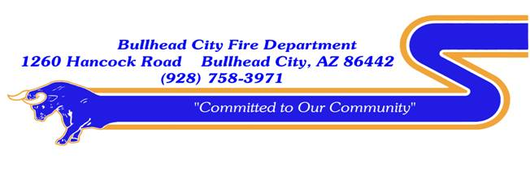

BOND OVERSIGHT COMMITTEE
PUBLIC NOTICE
AND AGENDA

The Bond Oversight Committee for the Bullhead City Fire District will meet on Friday, September 24, 2021, at 9:00 a.m. The meeting will be held at Bullhead City Fire Department located at 1260 Hancock Rd. Bullhead City, AZ 86442.

- CALL TO ORDER
- ROLL CALL
- CHIEF COMMENTS
- PUBLIC COMMENTS
The public is invited to directly address the committee on any item of interest that is within the subject matter jurisdiction of the Bond Oversight Committee. The committee is not permitted to take action on any item not appearing on the agenda. The chairperson may limit the time allocated to such comments from the public.

- BUSINESS
A. Approval of Meeting Minutes-October 13, 2020

B. Discussion only: Update for the Bullhead City Fire District Facility Committee related to the
construction/remodel of Station #2 and construction of the Laughlin Ranch Station #7

5. FUTURE AGENDA ITEMS

- ADJOURNMENT

Posted this 23rd day of September, 2021, by,

Paula Acker
Administrative Manager
Bullhead City Fire Department

Persons with a disability may request a reasonable accommodation for this meeting, by contacting Bullhead City Fire Department at 928-758-3971 at least 24 hours prior to the scheduled meeting time.

